**Logical data model**

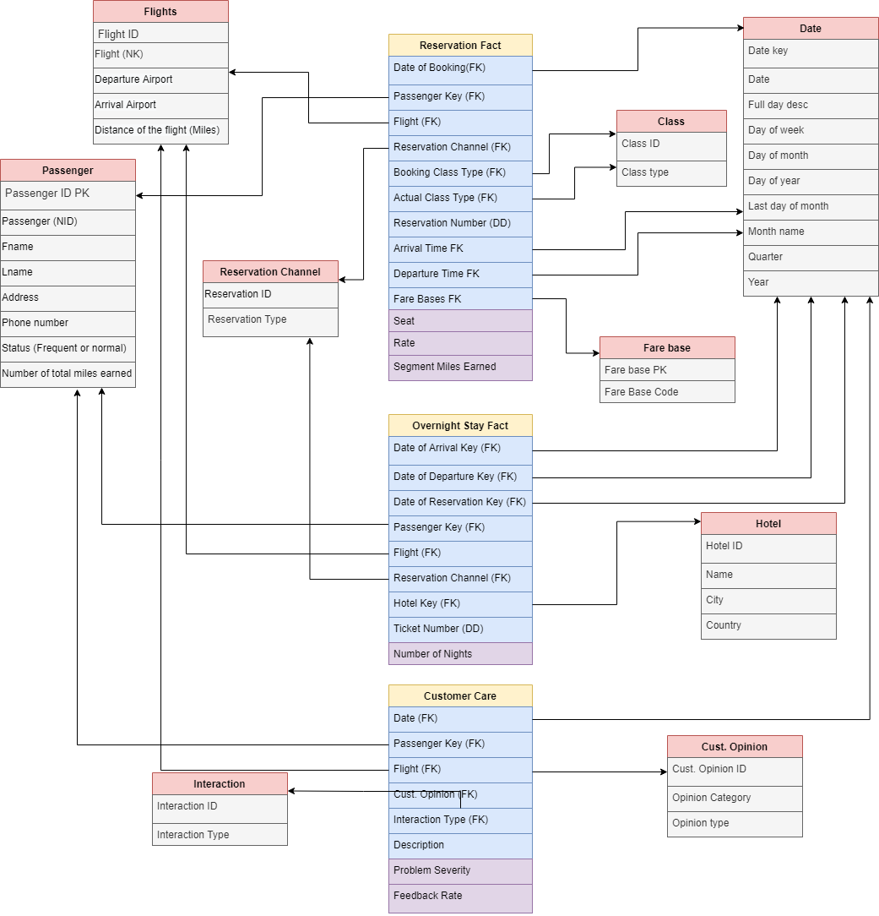

**Logical data model in details**

Using Galaxy schema to represent the model because the case study has many business processes.

**Grain**: per reservation.

**Reservation fact**: represent information about Reservation (Booking) such as date of booking, passenger ID, flight ID, reservation channel, booking class type, and the actual class in case the customer upgrade before the flight, time of departure and arrival, seat, rate and payment amount.

**Overnight stay fact**: represent the details of the date of arrival, departure and reservation, ticket number and reservation channel about passengers who spend a number of nights in hotel.

**Customer care fact**: as a program to take a feedback or problem severity from passenger.

**Flight’s dimension**: represent information about each flight, such as flight number, the departure and arrival airport and the distance of the flight in miles.

**Passenger dimension**: represent information about each Passenger, such as Passenger number, first and last name, address, phone number and weather this passenger is a normal one or frequent one (status) and keep track of the number of miles he earns.

**Data dimension**: represent date, date of week, date of month, date of year, month number, quarter, year.

**Fare bases dimension**: represent the terms surrounding the fare ex full fare economy, full fare first class, full fare business or discount economy, discount first class, discount business.

Clarify fare basis table, shortcuts stands for:

F1 : full fare first class

FB : full fare business class

FC : full fare economy class

D1 : discount fare first class

DB : discount fare business class

DC : discount fare economy class

**Reservation channel dimension**: represent the method that passenger use to make the reservation.

**Class type dimension**: represent whether the passenger sat in economy, business, or first class.

**Hotel dimension**: represent information about the hotel that the passenger spend number of nights in it.

**Cust. Opinion dimension**: represent a type of opinion of passenger if it’s a feedback, inquiries or complain.

**Interaction type dimension**: represent the time of feedback or complain before/after/within the flight.

**Bus matrix for business processes against common dimensions**

|  |  |  |  |  |  |  |  |  |  |
| --- | --- | --- | --- | --- | --- | --- | --- | --- | --- |
|  | Date | Flight | Passenger | Reservation Channel | Class | Fare Base | Hotel | Cust. Opinion | Cut. Interaction |
| Reservation | ✓ | ✓ | ✓ | ✓ | ✓ | ✓ |  |  |  |
| Overnight Stay | ✓ | ✓ | ✓ | ✓ |  |  | ✓ |  |  |
| Customer Care | ✓ | ✓ | ✓ |  |  |  |  | ✓ | ✓ |